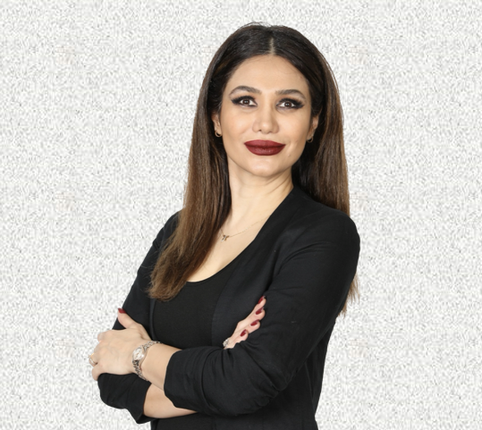
Mahdis Miller
Mahdis0027@gmail.com
(805) 302-9560
19031 Bessemer Street
Tarzana, CA 91335

Motivated, studious, and solutions-oriented computer engineering and coding professional. I am seeking hands-on experience developing the front-end of websites and applications in a fast-paced environment. I am also interested in roles as a full-stack developer, back-end web developer, web designer, Java application developer, or MERN developer.

KEY AREAS OF EXPERTISE
Currently, I am more than halfway through the UCLA Extension Full Stack Web Development Coding Boot Camp (COM SCI 900.001), and have hands-on experience and/or exposure to the following:
- Browser Based Languages (HTML, HTML 5, CSS, CSS3, JavaScript, jQuery, Bootstrap)
- Databases (MySQL, MongoDB)
- Deployment (Heroku, Git)
- Java
- Quality Assurance
- Server Side Development (Node.js, Express.js, React.js, MERN Stack)

EDUCATION
- UCLA Extension Full Stack Web Development Coding Boot Camp (COM SCI 900.001)
  - Certificate of Completion, 12 weeks, October 2022 – March 2023 (anticipated)
- Aveda Institute Los Angeles, Westwood, CA
  - Esthetician Certificate of Completion 600 hours, May 2017

- Los Angeles County High School for the Arts, Los Angeles, CA
  - Acting Certificate of Completion, June 2015

- Azad Tehran Shomal, Tehran, Iran
  - Masters of Sociology, May 2006

- University of Guilan, Rast, Iran
  - Bachelor of the Arts, May 2003
  - Major: English Literature

EXPERIENCE
- UCLA Extension Full Stack Web Development Coding Boot Camp (COM SCI 900.001)
  - October 2022 – March 2023
- The Spa at The Bicycle Hotel & Casino, Bell Gardens, CA
- Lead actress in multiple Farsi programs on GEM TV
- Board of Barbering and Cosmetology
  - Licensed Esthetician, State of California, No. Z 125963 (expired)
- Elite Permanent Makeup & Training Center
  - Microblading Technique Certificate of Completion, No. 20321
  - Awarded July 19, 2018

SPECIAL SKILLS: Fluent in English and Farsi (Persian)

